BILLING POLICY

Thank you for choosing All In Aviation for your flight training!
Please review the billing terms below and sign that you understand and agree.
For any additional billing questions please contact Tess directly.

- All invoices will be emailed to you, the client, after your appointment.
- Invoices are emailed through QuickBooks directly and need to be paid through the link on the email.
- If you have money on account to cover the invoice you will still receive an emailed invoice for your appointment. The balance due will show $0.
- A valid credit card on account is mandatory before any training can start. Any time a credit card is used there will be a 3% processing fee added. Please enter your card information at the link provided.
- If you previously had money on account and receive an invoice email showing a balance due, it means you have exhausted your credit and now owe that amount.
***The credit card put on file is NOT automatically charged for invoices unless you inform us to do so***
- Any invoices over 3 days past due can be charged to your card on file. We are not required to notify you additionally before charging your card for past due invoices.
- All expenses incurred during lessons or trips are billed to you, the client.
- Fuel purchased outside of AIA is to be paid by you, the client.
- If you purchase fuel and would like credit back, you must submit your receipt to tess@allinaviation.com including your full name. Reimbursement will be made on your invoice and fuel is reimbursed per gallon up to the current SS rate at KHND.

AIA Membership Information

- Membership is voluntary. You are welcome to sign up for a membership at any time.
- To become a member, please email tess@allinaviation.com and Tess will set up your account for you.
- Initial membership sign up is $550. This includes the first 6 months dues up front and a refundable insurance deposit. Once the initial 6 months is complete, dues go to automatic monthly billing of $50.
- You can cancel your membership at any time by emailing Tess. Initial membership dues paid are nonrefundable.
- You are welcome to put a deposit on account in the form of check, cash, credit card or bank wire. If you chose to use your credit card the 3% fee will be applied.
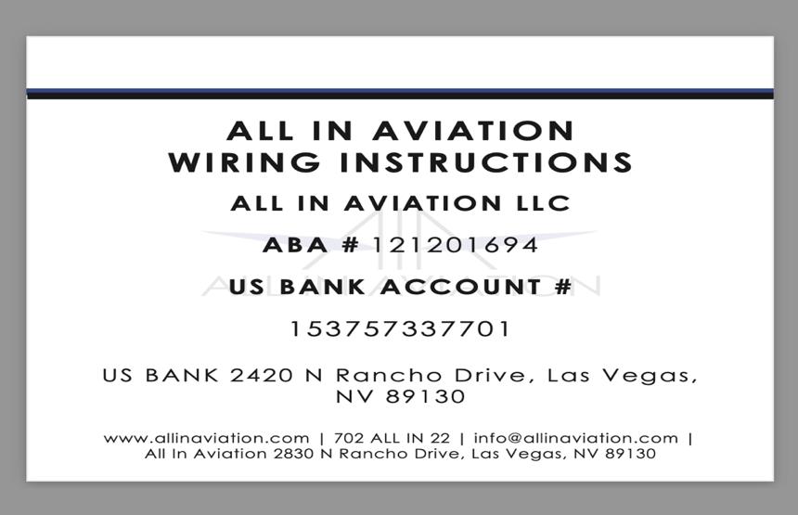
- If sending a bank wire, an email to Tess including your full name and wire confirmation information is required.
- If there is a balance due on your account, this will need to be paid in full before bonus credit is given.
- Additional details pertaining to the membership benefits, including a breakdown of bonus credit amounts, can be found on the AIA price sheet.

I _____________________________________________ have read, understand and agree to these Terms.

Signature _______________________________________________ Date______________________

